KIỂM TRA GIỮA KỲ MÔN: THỰC HÀNH CƠ SỞ DỮ LIỆU 20232

 Họ tên sinh viên:  Lương Văn Khanh        MSSV: 20225728

**Câu 1.**

*SQL:*

*CREATE TABLE library.Book (*

*book_id char(10) PRIMARY KEY,*

*title char(50) NOT NULL,*

*publisher char(20) NOT NULL,*

*published_year integer CHECK (published_year > 1900),*

*total_number_of_copies integer CHECK (total_number_of_copies >= 0),*

*current_number_of_copies integer CHECK (current_number_of_copies >= 0),*

*CHECK (total_number_of_copies >= current_number_of_copies)*

*);*

*CREATE TABLE library.Borrower (*

*borrower_id char(10) PRIMARY KEY,*

*name char(50) NOT NULL,*

*address text,*

*telephone_number char(12)*

*);*

*CREATE TABLE library.BorrowCard (*

*card_id int PRIMARY KEY,*

*borrower_id char(10) REFERENCES library.Borrower(borrower_id),*

*borrow_date date NOT NULL,*

*expected_return_date date NOT NULL,*

*actual_return_date date*

*);*

*CREATE TABLE library.BorrowCardItem (*

*card_id int,*

*book_id char(10),*

*number_of_copies integer,*

*PRIMARY KEY (card_id, book_id),*

*FOREIGN KEY (card_id) REFERENCES library.BorrowCard(card_id),*

*FOREIGN KEY (book_id) REFERENCES library.Book(book_id)*

*);*

**Câu 2.**

*SQL:*

*SELECT * FROM library.Book*

*WHERE published_year = 2012 AND publisher = 'Wiley';*

*Kết quả*

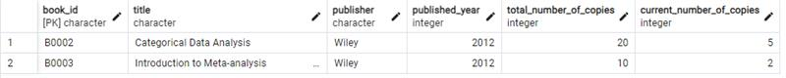

**Câu 3.**

*SQL:*

*SELECT publisher, COUNT(*) AS total*

*FROM library.Book*

*GROUP BY publisher;*

*Kết quả:*

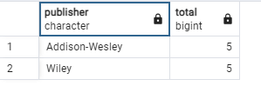

**Câu 4.**

*SQL:*

SELECT Book.book_id, Book.title

FROM library.Book

JOIN library.BorrowCardItem ON Book.book_id = BorrowCardItem.book_id

JOIN library.BorrowCard ON BorrowCardItem.card_id = BorrowCard.card_id

WHERE EXTRACT(YEAR FROM BorrowCard.borrow_date) = 2024

GROUP BY Book.book_id, Book.title

ORDER BY COUNT(*) DESC

LIMIT 5;

*Kết quả:*

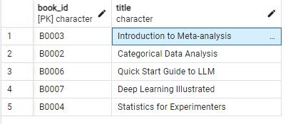

**Câu 5.**

*SQL:*

SELECT Borrower.borrower_id, Borrower.name, Borrower.telephone_number, Borrower.address

FROM library.Borrower

LEFT JOIN BorrowCard ON Borrower.borrower_id = BorrowCard.borrower_id

WHERE BorrowCard.actual_return_date IS NULL;

*Kết quả:*

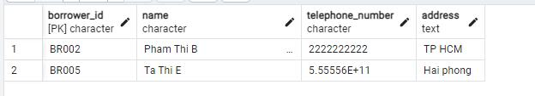

**Câu 6.**

*SQL:*

SELECT Borrower.borrower_id, Borrower.name, Borrower.telephone_number, Borrower.address

FROM library.Borrower

JOIN library.BorrowCard ON Borrower.borrower_id = BorrowCard.borrower_id

WHERE library.BorrowCard.actual_return_date > BorrowCard.expected_return_date

ORDER BY library.Borrower.name;

*Kết quả:*

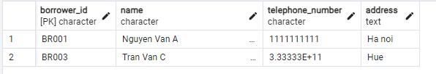

**Câu 7.**

*SQL:*

*DELETE FROM library.Book*

*WHERE book_id NOT IN (*

*SELECT book_id*

*FROM library.BorrowCardItem*

*);*

*Kết quả:*

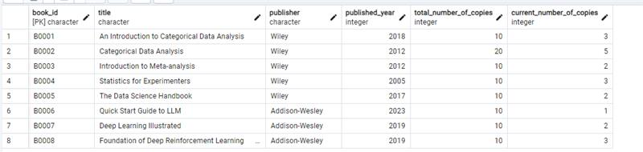

**Câu 8.**

*SQL:*

*UPDATE library.Book*

*SET total_number_of_copies = total_number_of_copies + 10*

*WHERE book_id IN (*

*SELECT library.book_id*

*FROM (*

*SELECT BorrowCardItem.book_id, COUNT(*) AS borrow_count*

*FROM library. BorrowCardItem*

*JOIN library. BorrowCard ON BorrowCardItem.card_id = BorrowCard.card_id*

*JOIN library. Book ON BorrowCardItem.book_id = Book.book_id*

*WHERE Book.publisher = 'Wiley'*

*GROUP BY BorrowCardItem.book_id*

*ORDER BY borrow_count DESC*

*LIMIT 3*

*) AS top_books*

*);*

*Kết quả:*

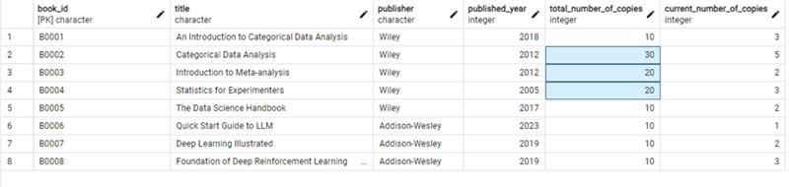

**Câu 9.**

*SQL:*

*SELECT Borrower.borrower_id, Borrower.name*

*FROM library.Borrower*

*JOIN BorrowCard ON Borrower.borrower_id = BorrowCard.borrower_id*

*JOIN BorrowCardItem ON BorrowCard.card_id = BorrowCardItem.card_id*

*JOIN Book ON BorrowCardItem.book_id = Book.book_id*

*WHERE Book.publisher IN ('Wiley', 'Addison-Wesley')*

*GROUP BY Borrower.borrower_id, Borrower.name*

*HAVING COUNT(DISTINCT Book.publisher) = 2;*

*Kết quả:*

